Charles Casale, Esq. Case Management System

- TEAM MEMBERS:
Jason Chandler
Chiemela Francis
Stephen Escalante
- CUSTOMER STATEMENT OF REQUIREMENTS:
2.1 PROBLEM STATEMENT:
Casale’s current case and client management system is inefficient, taking time away from his cases. He has recently downsized his practice. He no longer employs full-time paralegals, so he must handle his administrative work himself. He relies on physical files that are unorganized and not labeled, making it difficult to quickly locate documents. He wastes time searching that he could spend reviewing his cases. Meeting scheduling and management is cumbersome. He currently relies on his memory or disorganized paper notes to remember the times he scheduled. Creating and modifying meetings requires timely direct communication. These factors increase the risk of missed appointments and miscommunication.
Casale also struggles with managing case information and communicating it with his clients and temporary paralegals. He relies on phone calls and emails to communicate case deadlines and statuses. He establishes self-imposed task deadlines for his clients and paralegals through direct communication. The lack of clear documentation confuses himself and his users, often leading to missed deadlines and goals. Similarly, Casale manually tracks his billable hours, fees, and retainer balances, taking time from cases and potentially causing errors.
2.2 PROPOSED SOLUTIONS:
A centralized, secure, and user-friendly case management web application will streamline Casale’s workflow. He will be able to clearly communicate information with his clients and paralegals, significantly reducing his time spent on administrative work. The application will communicate meeting, case, and task information to relevant users. In addition, the site will host his documents, allowing him to easily access them anywhere. Casale will also be able to quickly reference his legal clients’ and paralegal’s information, updating their selective access to the site’s information as needed.
Users will create or edit meetings directly on the website. Casale will designate unavailable times for meetings and have the option to cancel, edit, and delete them, removing the need for Casale to manually schedule them and ensuring that both parties attend meetings. Additionally, Casale will upload case information to the application and specify relevant users to access it. The website will also make it easier for Casale to assign tasks and communicate their status to his clients and paralegals, who will have the option to complete the tasks digitally. A document page with a search function will greatly reduce the time Casale spends scouring through his physical files. The list of users will make communication much easier for Casale, and his ability to designate access to these users will save him time sharing information.
Major Functional Features Summary:
The attorney will be able to:
- Schedule and manage meetings – Create and edit without direct communication, automatically rejecting meetings with unsuitable times.
- Digitally manage cases – Add and access case information from anywhere.
- Track tasks – Create and monitor goals with documented due dates.
- Record hours and fees – Directly log time and money spent on cases, communicating it with the associated client.
- View users – Easily access user information and update their uses of the website.
Clients will be able to
- Schedule and view their meetings – Book appointments quickly through the website, instantly learning of any time conflicts.
- View their case information – Access the key information, including dates, addresses, and parties.
- View and complete their tasks – See what the attorney requires of them and instantly submit their progress.
Paralegals will be able to:
- Schedule and view their meetings – Book appointments quickly through the website, instantly learning of any time conflicts.
- View and complete their tasks – See what the attorney requires of them and instantly submit their progress.
2.3 NOVELTY:
The system designers researched similar software systems to ensure uniqueness. Two popular case management systems are MyCase and Clio. MyCase allows attorneys to organize case, client, and billing information similarly to the proposed project. MyCase enables communication between attorneys and clients. MyCase charges a monthly subscription starting at $39 per month for its basic plan. Clio focuses on information organization, time tracking, calendaring, and payments. Its basic tier costs $49 per month.
The proposed project is more beneficial than other case management systems. Firstly, the carefully crafted system will evolve to Casale’s specific needs during the development process. Ensuring usability with intuitive graphical user interfaces will ensure that the tool increases productivity. The proposed system is more flexible for single attorneys. It will allow Casale to access outside help and share relevant information as needed. Finally, the proposed system is free, saving money on the monthly subscription cost required for other similar services.
- Glossary of Terms:
- Billable hours: time spent on a case that the client is charged for.
- Case: a legal proceeding for a client.
- Case deadlines & statuses: official deadlines and statuses from the court.
- Case management system: a software system that organizes client data and documents for an attorney.
- Centralized: a centralized server will allow access to information anywhere.
- Fees: special costs clients must pay for.
- Role-based permissions: levels of access that dictate what a user can do.
- Retainer: a deposit from a client for the attorney’s services.
- Task deadlines: Casale’s personal goals for progress in a case.
- SYSTEM REQUIREMENTS
4.1 ENUMERATED FUNCTIONAL REQUIREMENTS
Identifier | Priority | Requirement
REQ-1 | 5 | The system shall allow clients to schedule meetings.
REQ-2 | 5 | The system shall allow the attorney to change meeting statuses.
REQ-3 | 5 | The system shall allow the attorney to set acceptable meeting times.
REQ-4 | 5 | The system shall allow participants to edit their meetings.
REQ-5 | 5 | The system shall allow participants to delete their meetings.
REQ-6 | 2 | The system shall send email notifications to participants when meetings are created.
REQ-7 | 2 | The system shall send email notifications to participants when meetings are edited.
REQ-8 | 5 | The system shall display the count of case statuses.
REQ-9 | 5 | The system shall allow participants to view a list of their scheduled meetings.
REQ-10 | 5 | The system shall store information on cases.
REQ-11 | 5 | The system shall allow the attorney to create new cases.
REQ-12 | 5 | The system shall allow the attorney to upload case information.
REQ-13 | 5 | The system shall allow the attorney to edit case information.
REQ-14 | 5 | The system shall display case information.
REQ-15 | 5 | The system shall store documents.
REQ-16 | 5 | The system shall display documents to relevant users.
REQ-17 | 5 | The system shall allow the attorney to request documents from clients.
REQ-18 | 5 | The system shall allow users to complete tasks digitally.
REQ-19 | 5 | The system shall allow the attorney to assign tasks to clients.
REQ-20 | 5 | The system shall allow the attorney to assign tasks to paralegals.
REQ-21 | 5 | The system shall allow clients to view their tasks.
REQ-22 | 5 | The system shall allow paralegals to view their tasks.
REQ-23 | 5 | The system shall report task completion status.
REQ-24 | 5 | The system shall allow the attorney to update the status of tasks.
REQ-25 | 5 | The system shall allow users to upload documents.
REQ-26 | 5 | The system shall allow the attorney to track his billable hours for cases.
REQ-27 | 5 | The system shall allow the attorney to track his fees for cases.
REQ-28 | 5 | The system shall display retainer balances for cases.
REQ-29 | 5 | The system shall calculate retainer balances for cases.
REQ-30 | 5 | The system shall allow users to sort their cases.
REQ-31 | 5 | The system shall allow users to sort their tasks
REQ-32 | 5 | The system shall allow the attorney to log in.
REQ-33 | 5 | The system shall allow paralegals to log in.
REQ-34 | 5 | The system shall allow legal clients to log in.
REQ-35 | 2 | The system shall create business reports on the profitability of case types.
REQ-36 | 2 | The system shall create business reports on the most profitable times of year.
REQ-37 | 5 | The system shall allow the attorney to delete cases.
REQ-38 | 5 | The system shall allow the attorney to view all users.
REQ-39 | 5 | The system shall allow the attorney to edit user roles.
REQ-40 | 5 | The system shall display information that users search for.
REQ-41 | 5 | The system shall allow users to sort their meetings.
4.1.1 Analysis: Enumerated Functional Requirements
Meeting scheduling is a significant system function. Clients shall use the system to create meetings with the attorney (REQ-1). The attorney should designate acceptable meeting times and confirm meetings (REQ-2/REQ-3). Users will edit (REQ-4) or cancel (REQ-5) their meetings. Participants will receive emails for meeting edits (REQ-6) and meeting cancellations (REQ-7). The system will count the number of pending and scheduled cases (REQ-8) and will display a list of individual meetings (REQ-9). Users may search (REQ-40) and sort (REQ-42) these meetings.
Case management is another significant function. The system will store case information, such as the title and court (REQ-10). Users will be able to search for cases, looking for a key term in their name or description (REQ-40). The attorney will create cases on the system (REQ-11) and be able to upload and edit their information (REQ-12/REQ-13). The attorney and his clients will view their case information on the system (REQ-14). Documents will be stored by case (REQ-15). Participating users shall view the documents (REQ-16). The attorney will have the option to request documents from clients on the system (REQ-17), and clients can upload their requested documents (REQ-18). The system will allow users to sort their viewable cases by case type (REQ-30) and by date (REQ-31). The system will allow the attorney to log billable hours (REQ-26) and fees (REQ-27) for cases. It will display this information to relevant users (REQ-28). It will calculate the retainer balance using this information (REQ-29). Additionally, the attorney will have the option to delete cases (REQ-37).
The attorney will upload tasks to clients (REQ-19) and paralegals (REQ-20) on the system, organized by case. He will be able to view all of the system’s users (REQ-38), and he may change their role (REQ-39). All user types will be able to view their tasks (REQ-21/REQ-22). The system will clearly display the status of the task (REQ-23), and the attorney will be able to update it as needed (REQ-24). Document uploads will be available to assignees (REQ-25). Users will be able to view their documents on a separate page (REQ-41). They may search for key terms in document names (REQ-40).
Tracking financial information is another key function. The attorney shall use the system to track his billable hours by case, which involves specifying the time and reason (REQ-26). He will also track fees by case on the system (REQ-27). Using this, the system will calculate (REQ-29) and display (REQ-38) retainer balances. For valuable business insights, the system will generate reports on the case types that make the most profit (REQ-35). Likewise, it will report the most profitable times of year (REQ-36).
The website will allow the attorney to view the system’s users (REQ-38). He will access their full names, contact information, addresses, and system roles. He will have the ability to change their roles, increasing or decreasing their site access (REQ-41).
4.2 ENUMERATED NONFUNCTIONAL REQUIREMENTS
Identifier | Type | Priority | Requirement
NFR-1 | Security | 5 | The system shall ensure secure authentication so only the authorized users access the appropriate data.
NFR-2 | Security | 5 | The system shall protect sensitive information through secure storage
NFR-3 | Performance | 3 | The system shall respond to user actions within 2 seconds under normal conditions.
NFR-4 | Operability | 5 | The system shall allow users to add data to the system in 4 or less clicks.
4.2.1 Analysis: Enumerated Non-Functional Requirements
The Non-Functional Requirements (NFRs) ensure security, reliability and operability of the system. Security is a significant priority, as the application stores sensitive client information. NFR-1 and NFR-2 through restricted access and secure storage. The performance requirement (NFR-3) ensures that the users do not wait long for the system’s response, ensuring that they use the system effectively. Lastly, NFR-4 guarantees that users can interact with the system easily. These four non-functional requirements ensure that the system functions securely and efficiently in a real world environment.
4.3 ON-SCREEN APPEARANCE REQUIREMENTS
Identifier | Priority | Requirement
OSAR-1 | 5 | The system shall display key information (meetings, cases, tasks, etc) in a clearly-labeled, modular format.
OSAR-2 | 5 | The system shall display a confirmation or error message after a form is submitted
OSAR-3 | 5 | The system shall display input forms as pop-ups on the current page.
4.3.1 Analysis: On-Screen Appearance Requirements
These requirements focus on ensuring that the system presents information in a clear organized way for the lawyer and clients. Key elements, such as the meeting or case details, are displayed in a modular feed format, making them easy to read and understand (OSAR-1). The system also provides feedback through confirmation or error messages after user input through OSAR-2. Lastly, the system will accept input in a few clicks (OSAR-3), maximizing ease of use.
- FUNCTIONAL REQUIREMENTS SPECIFICATION
5.1 STAKEHOLDERS
The stakeholders for this system include the following:
Charles Casale (Attorney)
The primary stakeholder of the system is Charles Casale, the attorney who will use the application to manage his cases, clients, and meetings. The system will allow him to organize case information, assign tasks, track billable hours, and manage client documents. By automating these tasks, the system will improve productivity and reduce time spent on manual administrative work.
Clients
Clients are indirectly affected stakeholders because their case information, documents, and meetings will be stored within the system. Clients may upload documents, participate in scheduled meetings, and update task statuses. The system helps ensure their case information is organized and accessible.
Paralegals
Paralegals working with Casale may also use the system to complete tasks assigned by the attorney. They may upload documents, update task progress, and assist with case preparation. The system allows them to collaborate efficiently with Casale.
5.2 ACTORS AND GOALS
The actors and their goals include:
Attorney
The attorney manages the entire system. His goals include uploading case information, assigning tasks, scheduling meetings, reviewing documents, tracking billable hours, and generating reports. The attorney also manages users such as clients and paralegals.
Clients
Clients interact with the system to view their case details, upload requested documents, attend scheduled meetings, and update task statuses. Their goal is to easily provide information required for their legal cases. They will view up-to-date information of what the attorney needs from them and the status of their cases.
Paralegals
Paralegals help the attorney manage cases by completing assigned tasks and uploading documents. Their goal is to assist the attorney in completing case-related work efficiently.
Database/System
The system database stores all information related to cases, documents, meetings, tasks, users, and payments. Its goal is to maintain accurate records and allow the application to retrieve information quickly.
5.3 USE CASE CASUAL DESCRIPTION
UC-1 Login User
Allows users to log into the system using their credentials.
UC-2 View Meetings
Allows users to view their meetings.
UC-3 Create Meeting
Allows users to schedule new meetings.
UC-4 Edit Meeting
Allows users to edit their meeting details.
UC-5 Delete Meeting
Allows users to delete their scheduled meetings.
UC-6 Sort Meetings
Allows users to sort their meetings by status.
UC-7 Update Meeting Status
Allows the attorney to update the status of meetings.
UC-8 View Cases
Allows users to view their case’s details.
UC-9 Create Case
Allows the attorney to create cases.
UC-10 Edit Case
Allows the attorney to edit cases.
UC-11 Delete Case
Allows the attorney to delete cases.
UC-12 Sort Case
Allows users to sort their cases by case type, status, and dates.
UC-13 View Tasks
Allows users to view their tasks.
UC-14 Create Task
Allows the attorney to create new tasks.
UC-15 Edit Task
Allows the attorney to edit existing tasks.
UC-16 Complete Task
Allows users to complete their tasks.
UC-17 Update Task Status
Allows the attorney to update the status of tasks.
UC-18 Track Billable Hours & Fees
Allows the attorney to track time and fees spent on cases.
UC-19 View Billable Hours & Fees
Allows users to view time and fees spent on cases.
UC-20 View Users
Allows the attorney to view his client’s and paralegal’s personal details.
UC-21 Update User Role
Allows the attorney to change the role of users.
UC-22 View Documents
Allows users to view their documents.
UC-23 Upload Document
Allows users to upload documents to the system.
UC-24 Search Page
Allows users to search for pages for desired information.
UC-25 Set Unavailable Time
Allows the attorney to designate times unavailable for meetings.
5.4 USE CASE ANALYSIS
UC-1 allows users to log into the system. The system verifies the user’s login information and grants access to the appropriate functions depending on their role (client, paralegal, or attorney). This ensures secure access to the system’s data, as users will have limited access to system functionalities. The major function pages will have individual search bars (UC-24), which will make accessing specific information as easy as possible.
UC-2 allows users to view their meetings. They must see the time, status, duration, and location. The system will allow the user to sort their meetings (UC-6). UC-3 allows clients and paralegals to create meetings with the attorney, and it allows the attorney to select a specific user to meet with. The system will allow users to edit (UC-4) and delete (UC-5) their meetings. UC-7 allows the attorney to update the meeting status separately from editing the entire meeting.
UC-8 allows users to view their cases. The system will communicate key information: the title, court, case type, filing date, and status. Users will only see cases they are part of. UC-12 will allow users to sort their cases. Only the attorney will have the option to create (UC-9), edit (UC-10), or delete (UC-11) cases from the system. The case hours and fees are crucial information that the attorney must log (UC-18). UC-19 will allow users to view these tracked hours & fees.
The system stores tasks that are set by the attorney. Users will view their tasks with UC-13. UC-14 allows the attorney to create these tasks, which includes adding a user. The attorney will have the option to edit these tasks (UC-15). Users may complete their task digitally with UC-16. UC-17 will allow the attorney to update the task status.
UC-20 will allow the attorney to view the users of the system. This will display their full names, contact information, address, and role. The attorney will be able to update the role of his clients and paralegals (UC-21) to give them access to the correct information and functions.
They will also have the ability to upload documents (UC-23). The system will display the documents that they have access to (UC-22). UC-24 allows users to search for documents. The system will display the documents that they have access to (UC-22). Documents that have associated cases will be noted.
5.5 USE CASE DIAGRAM
Case Management System
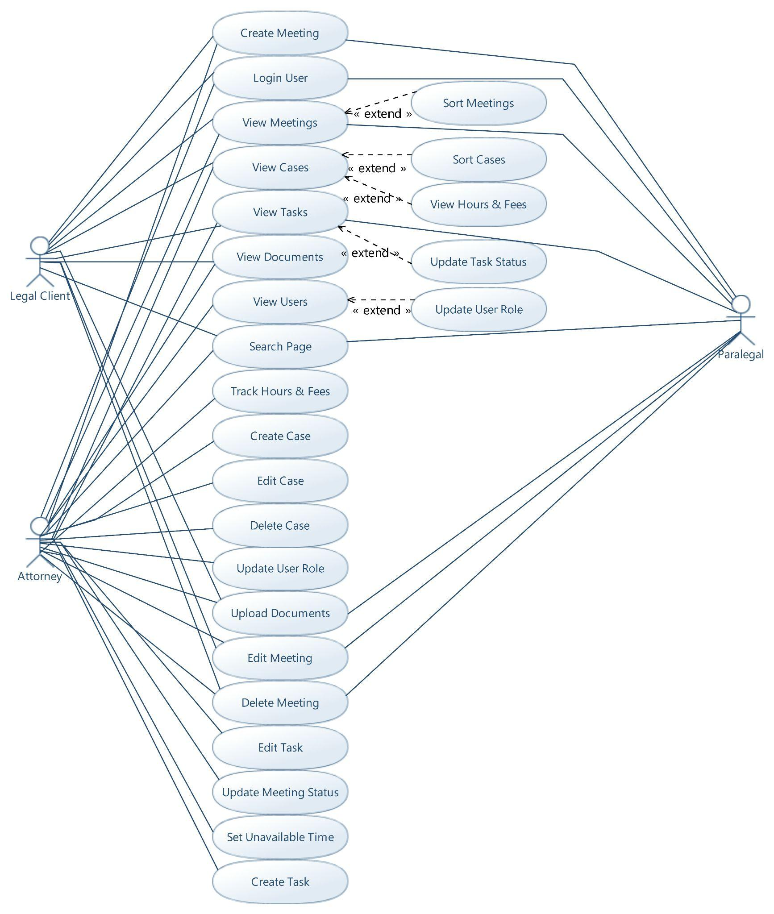
5.6 TRACEABILITY MATRIX
REQ | PW | UC  1 | UC  2 | UC  3 | UC  4 | UC  5 | UC  6 | UC  7 | UC  8 | UC  9 | UC  10 | UC  11 | UC  12 | UC  13 | UC  14 | UC  15 | UC  16 | UC  17 | UC  18 | UC  19 | UC  20 | UC  21 | UC  22 | UC  23 | UC  24 | UC  25
REQ-1 | 5 |  |  | X
REQ-2 | 5 |  |  |  |  |  |  | X
REQ-3 | 5 |  |  |  |  |  |  |  |  |  |  |  |  |  |  |  |  |  |  |  |  |  |  |  |  | X
REQ-4 | 5 |  |  |  | X
REQ-5 | 5 |  |  |  |  | X
REQ-6 | 2 |  |  | X
REQ-7 | 2 |  |  |  | X |  |  | X
REQ-8 | 5 |  |  |  |  |  |  |  | X
REQ-9 | 5 |  | X
REQ-10 | 5 |  |  |  |  |  |  |  |  | X
REQ-11 | 5 |  |  |  |  |  |  |  |  | X
REQ-12 | 5
REQ-13 | 5 |  |  |  |  |  |  |  |  |  | X
REQ-14 | 5 |  |  |  |  |  |  |  | X
REQ-15 | 5 |  |  |  |  |  |  |  |  |  |  |  |  |  |  |  |  |  |  |  |  |  | X
REQ-16 | 5 |  |  |  |  |  |  |  |  |  |  |  |  |  |  |  |  |  |  |  |  |  | X
REQ-17 | 5 |  |  |  |  |  |  |  |  |  |  |  |  |  | X
REQ-18 | 5 |  |  |  |  |  |  |  |  |  |  |  |  |  |  |  | X |  |  |  |  |  |  | X
REQ-19 | 5 |  |  |  |  |  |  |  |  |  |  |  |  |  | X
REQ-20 | 5 |  |  |  |  |  |  |  |  |  |  |  |  |  | X
REQ-21 | 5 |  |  |  |  |  |  |  |  |  |  |  |  | X
REQ-22 | 5 |  |  |  |  |  |  |  |  |  |  |  |  | X
REQ-23 | 5 |  |  |  |  |  |  |  |  |  |  |  |  | X
REQ-24 | 5 |  |  |  |  |  |  |  |  |  |  |  |  |  |  | X |  | X
REQ-25 | 5 |  |  |  |  |  |  |  |  |  |  |  |  |  |  |  | X |  |  |  |  |  |  | X
REQ-26 | 5 |  |  |  |  |  |  |  |  |  |  |  |  |  |  |  |  |  | X
REQ-27 | 5 |  |  |  |  |  |  |  |  |  |  |  |  |  |  |  |  |  | X
REQ-28 | 5 |  |  |  |  |  |  |  |  |  |  |  |  |  |  |  |  |  |  | X
REQ-29 | 5 |  |  |  |  |  |  |  |  |  |  |  |  |  |  |  |  |  |  | X
REQ-30 | 5 |  |  |  |  |  |  |  |  |  |  |  | X
REQ-31 | 5 |  |  |  |  |  |  |  |  |  |  |  | X | X
REQ-32 | 5 | X
REQ-33 | 5 | X
REQ-34 | 5 | X
REQ-35 | 2 |  |  |  |  |  |  |  |  |  |  |  |  |  |  |  |  |  | X | X
REQ-36 | 2 |  |  |  |  |  |  |  |  |  |  |  |  |  |  |  |  |  | X | X
REQ-37 | 5 |  |  |  |  |  |  |  |  |  |  | X
REQ-38 | 5 |  |  |  |  |  |  |  |  |  |  |  |  |  |  |  |  |  |  |  | X | X
REQ-39 | 5 |  |  |  |  |  |  |  |  |  |  |  |  |  |  |  |  |  |  |  |  | X
REQ-40 | 5 |  |  |  |  |  |  |  |  |  |  |  |  |  |  |  |  |  |  |  |  |  |  |  | X
REQ-41 | 5 |  |  |  |  |  | X
Max PW |  | 5 | 5 | 5 | 5 | 5 | 5 | 5 | 5 | 5 | 5 | 5 | 5 | 5 | 5 | 5 | 5 | 5 | 5 | 5 | 5 | 5 | 5 | 5 | 5 | 5
Total PW |  | 15 | 5 | 7 | 7 | 5 | 5 | 7 | 10 | 10 | 5 | 5 | 10 | 20 | 15 | 5 | 10 | 5 | 14 | 14 | 5 | 10 | 10 | 10 | 5 | 5
5.7 USE CASE FULLY-DRESSED DESCRIPTION
5.7.1 Login User
UC-1: Login User
Related Requirements | REQ-32, REQ-33, REQ-34
Primary Actors | Attorney, clients, paralegal
Actor’s goals | Access System
Secondary Actors | Database
Precondition: | - The user has an account.
Successful Postcondition: | - The user will have access to the system.
Failed Postcondition: | - The user will be denied access.
Flow of Events for Main Success Scenario:
→ 1. User navigates to the login page.
→ 2. User enters their email and password.
→ 3. User submits the login request.
← 4. System verifies the entered credentials.
← 5. System authenticates the user.
← 6. System assigns user session data.
← 7. System redirects the user to the appropriate dashboard.
Alternate Flows:
1A1: Invalid credentials
→ 1. User enters an incorrect email or password.
← 2. System detects invalid credentials.
← 3. System displays an error message.
→ 4. User must re-enter their login information.

1A2: Missing input fields
→ 1. User submits a form with missing fields.
← 2. System detects incomplete input.
← 3. System displays an error message.

5.7.2 View Meetings
UC-2: View Meetings
Related Requirements | REQ-9
Primary Actors | Attorney, clients, paralegals
Actor’s goals | To view scheduled meetings.
Secondary Actors | System
Preconditions: | - The user is logged into the system.  - The user has at least one meeting.
Successful Postcondition: | - The user will view a feed of their meetings.
Failed Postcondition:
Flow of Events for Main Success Scenario:
→ 1. User navigates to the Meetings page.
← 2. System retrieves meeting data from the database.
← 3. System calculates pending and upcoming meeting counts.
← 4. System displays the list of meetings with details.
Alternate Flows:
2A1: No meetings available
← 1. System finds no meeting records.
← 2. System displays a no meetings found error message.

5.7.3 Create Case
UC-9: Create Case
Related Requirements | REQ-10, REQ-11
Primary Actors | Attorney
Actor’s goals | To create a case on the system.
Secondary Actors | System
Preconditions: | - The attorney has the privilege to perform the action.
Successful Postcondition: | - The system will store the relevant case information.
Failed Postcondition:
Flow of Events for Main Success Scenario:
→ 1. Attorney navigates to the Cases page.
→ 2. Attorney fills out the create case form.
← 2. System inserts the form data into the Cases table.
Alternate Flows:
9A1: An insertion error occurs
← 1. System cannot insert the form input.
← 2. System displays the error message at the top of the page.

5.7.4 Track Billable Hours and Fees
UC-18: Track Billable Hours and Fees
Related Requirements | REQ-26, REQ-27, REQ-35, REQ-36
Primary Actors | Attorney
Actor’s goals | To record billable hours and fees for a case
Secondary Actors | System
Preconditions: | - The attorney must be logged into the system.  - A case must exist in the system.
Successful Postcondition: | - The database will store the hours or fees.
Failed Postcondition: | - The database will not store the new hours or fees.
Flow of Events for Main Success Scenario:
→ 1. Attorney navigates to a specific case.
→ 2. Attorney selects the tracking form.
→ 4. Attorney submits the form.
← 5. System validates the input data.
← 6. System stores the billable hours and fees in the database.
← 7. System confirms successful entry.
Alternate Flows:
18A1: Invalid input:
→ 1. User enters incomplete or incorrect data.
← 2. System detects invalid input.
← 3. System displays an error message.
→ 4. User corrects the input and resubmits.

5.7.5 Upload Documents
UC-23: Upload Documents
Related Requirements: | REQ-18, REQ-25
Primary Actors: | Attorney, clients, paralegals
Actor’s goals: | To upload documents.
Secondary Actors | System
Preconditions | - Users must be logged into the system.  - Users must have permission to upload documents.
Successful Postcondition: | - The system will store the document.  - The database will store the reference to the document.
Failed Postcondition: | - The system will not store the document.  - Nothing will be inserted into the database.
Flow of Events for Main Success Scenario:
→ 1. User navigates to the Documents page.
→ 2. User selects “Upload Document.”
→ 3. User enters the document name.
→ 4. User selects a file from their device.
→ 5. User submits the upload form.
← 6. System uploads the file to server storage.
← 7. System saves document information in the database.
← 8. System confirms successful upload.
Alternate Flows:
15A1: Upload failure
→ 1. User submits a file.
← 2. System detects an error.
← 3. System displays an error message.
→ 4. User attempts to upload again.

6. USER INTERFACE PRELIMINARY DESIGN

Navigation and Home Layout
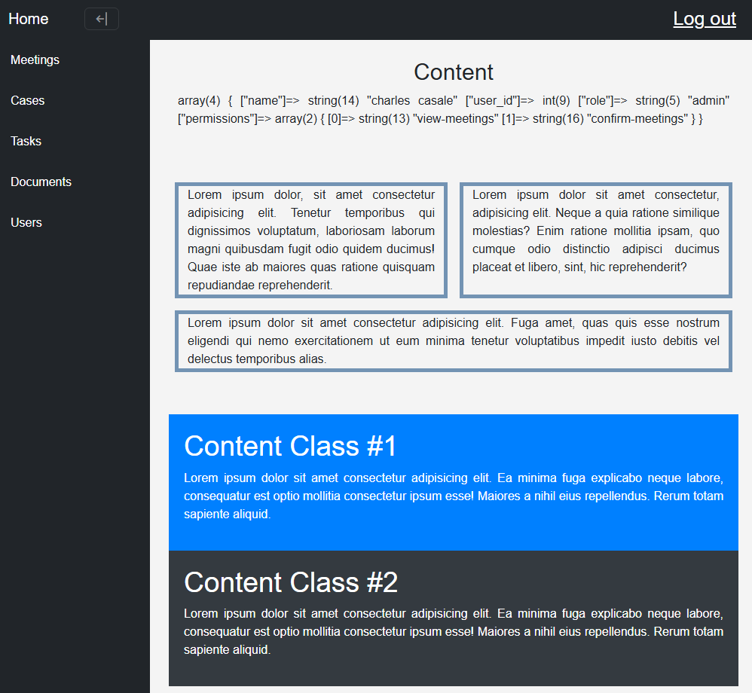
The system will include a top navigation bar and a side navigation menu. The top navigation bar will provide access to the home page and login/logout controls. The sidebar will provide links to the main modules of the system, including Meetings, Cases, Tasks, and Documents. This layout allows users to move between major pages without needing to return to the home screen each time. When on one of the sidebar pages, its block background color changes. For testing purposes, the main content has the variable dump and other filler content.

Login Screen
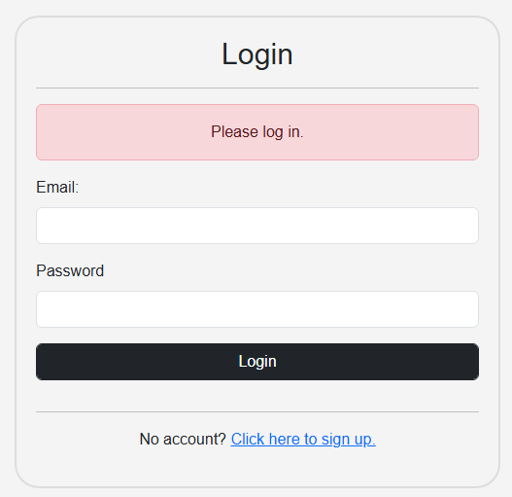
The login screen will allow users to enter their email and password to access the system. The page will contain labeled input fields, a login button, and a link to the signup page for users who do not already have an account. If login credentials are invalid, the interface will display an error message explaining that the login attempt failed. This screen is designed to be simple and direct so users can quickly access the system.
Meetings Dashboard
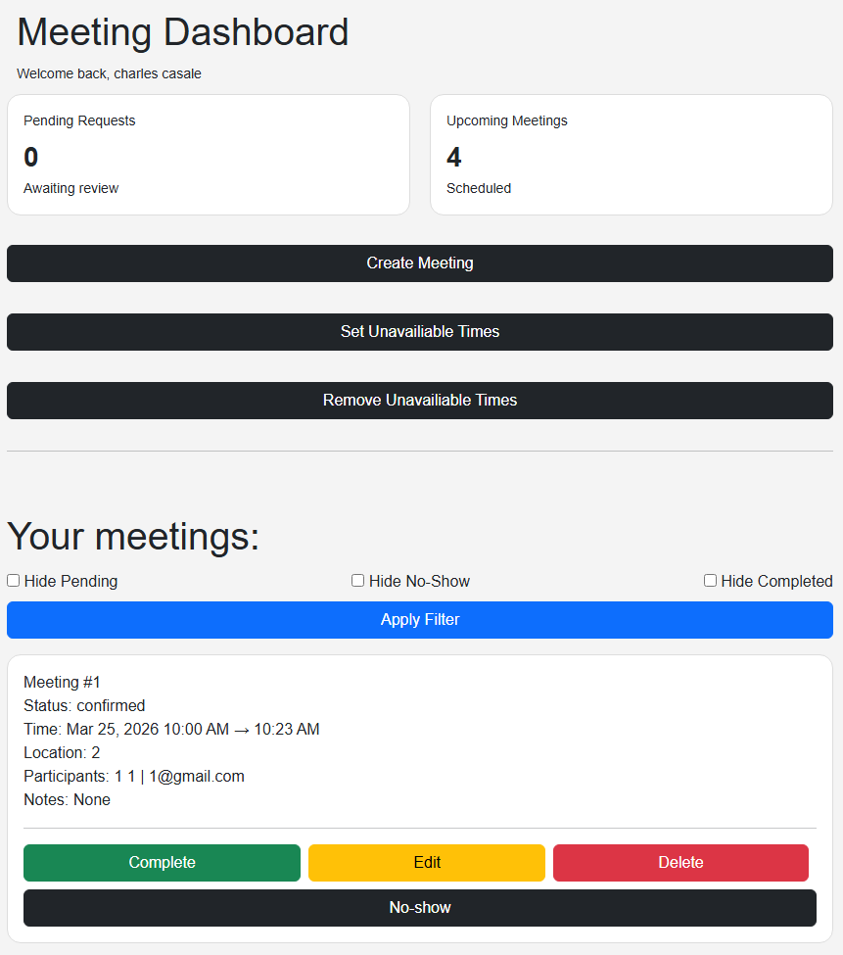
The Meetings page will serve as the main scheduling interface. At the top of the page, users will see summary cards showing values such as pending meeting requests and upcoming meetings. Below the summary area, users will be able to create new meetings by selecting a date, time, location, duration, and notes. If the logged-in user is the attorney, the form will also allow selection of a client or paralegal for the meeting.
Below the meeting creation area, the page will display a list of meetings relevant to the current user. Each meeting entry will show its status, scheduled date and time, location, and notes. If the attorney is viewing the page, participant information will also be displayed. Action buttons will appear depending on the user’s role and the meeting’s status. For example, the attorney may confirm, complete, or mark meetings as no-show, like in the example image. Clients and paralegals will only have the edit and delete options. This page will be the central location for meeting management.
Cases Screen

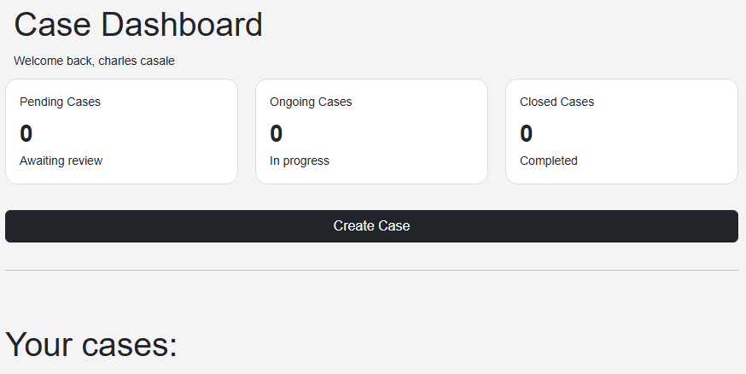
The Cases page will allow users to view case-related information. The attorney will be able to create, edit, and delete cases, while clients and paralegals will only be able to view cases that are relevant to them. Case records will be displayed in a structured format showing information such as case title, court, type, filing date, and status. The page will also support sorting cases by type and date so users can locate records more efficiently.
For attorneys, the case screen will eventually include controls for adding case information, uploading case materials, and managing case-related financial data such as billable hours, fees, and retainers. Clients and paralegals will have a simplified view that focuses only on the case information they are permitted to access.

Documents Screen
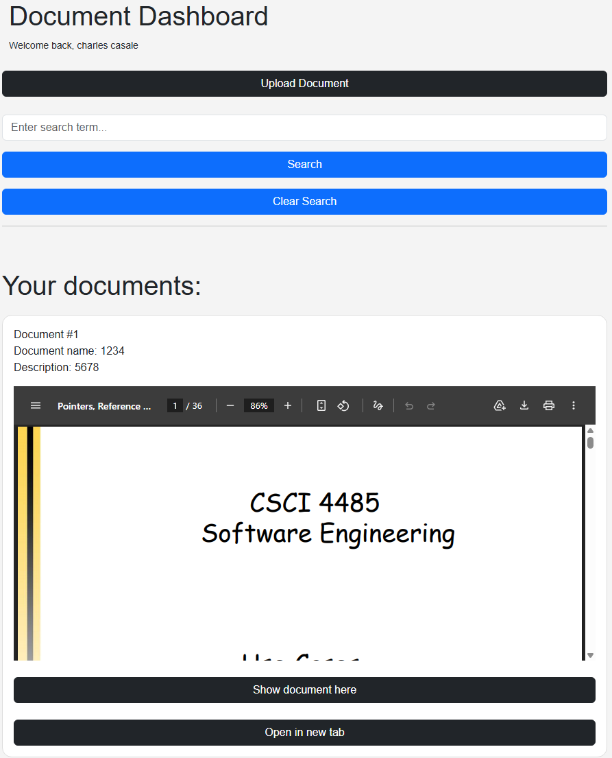
The Documents page will allow authorized users to upload and manage documents. The upload form will include fields for document name, file selection, and description. After submission, the document will be stored by the system and become available to the users with permission to view it. The document will be viewable in the current tab or full-screen in a new tab.

Users Screen
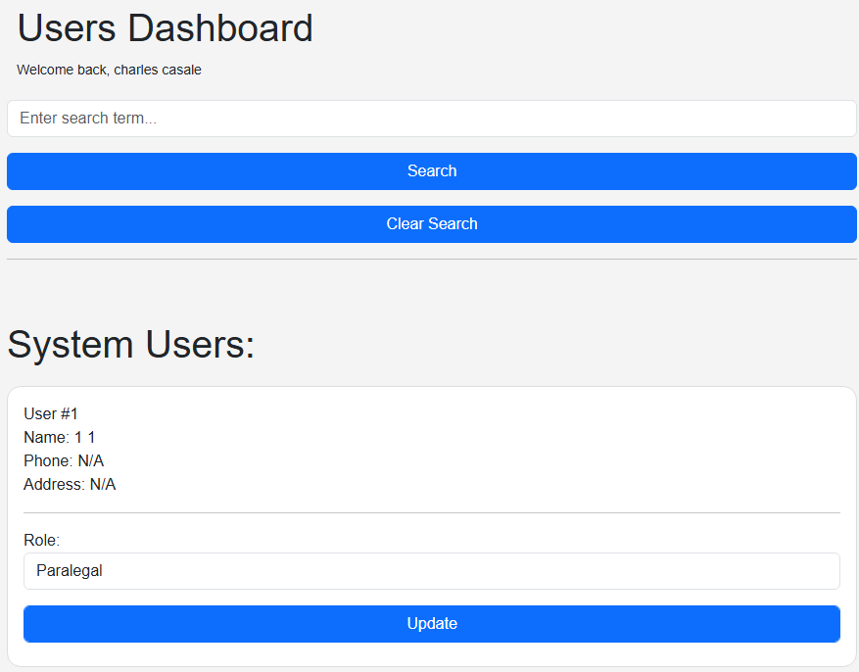

The Users page will allow the attorney to view all registered users in the system. The page will display user information in a structured table format, including first name, last name, email, phone number, address, and role. This screen supports the attorney’s administrative responsibilities by giving him a centralized view of clients and paralegals.
Only the attorney will have access to this page. Clients and paralegals will not be permitted to view the full user list. The page will also support role management by allowing the attorney to change a user’s role when needed. For example, a client may be updated to a paralegal if their responsibilities in the system change.
The interface will use a modular feed layout so records are easy to scan and compare. Action buttons such as Edit Role may appear beside each user record. When selected, the system may open a modal form that allows the attorney to choose a new role and save the update. This design keeps user administration simple and consistent with the rest of the system.
7. SYSTEM ARCHITECTURE AND SYSTEM DESIGN
7.1 ARCHITECTURAL STYLES
This case management system follows a three-tier architectural style. The client tier uses HTML, CSS, and JavaScript to handle user interactions, such as form submissions and navigation. The logic tier uses PHP to evaluate user input, dynamically generate content, and communicate data between the other two layers. The data tier is implemented with MySQL, while uploaded documents are stored in the file system and accessed using fields from the Documents table. The logic tier requests and processes data retrieved from the data tier, which is then sent to the presentation layer for display to the user.
7.2 DATABASE DESIGN
7.2.1 E-R Diagram
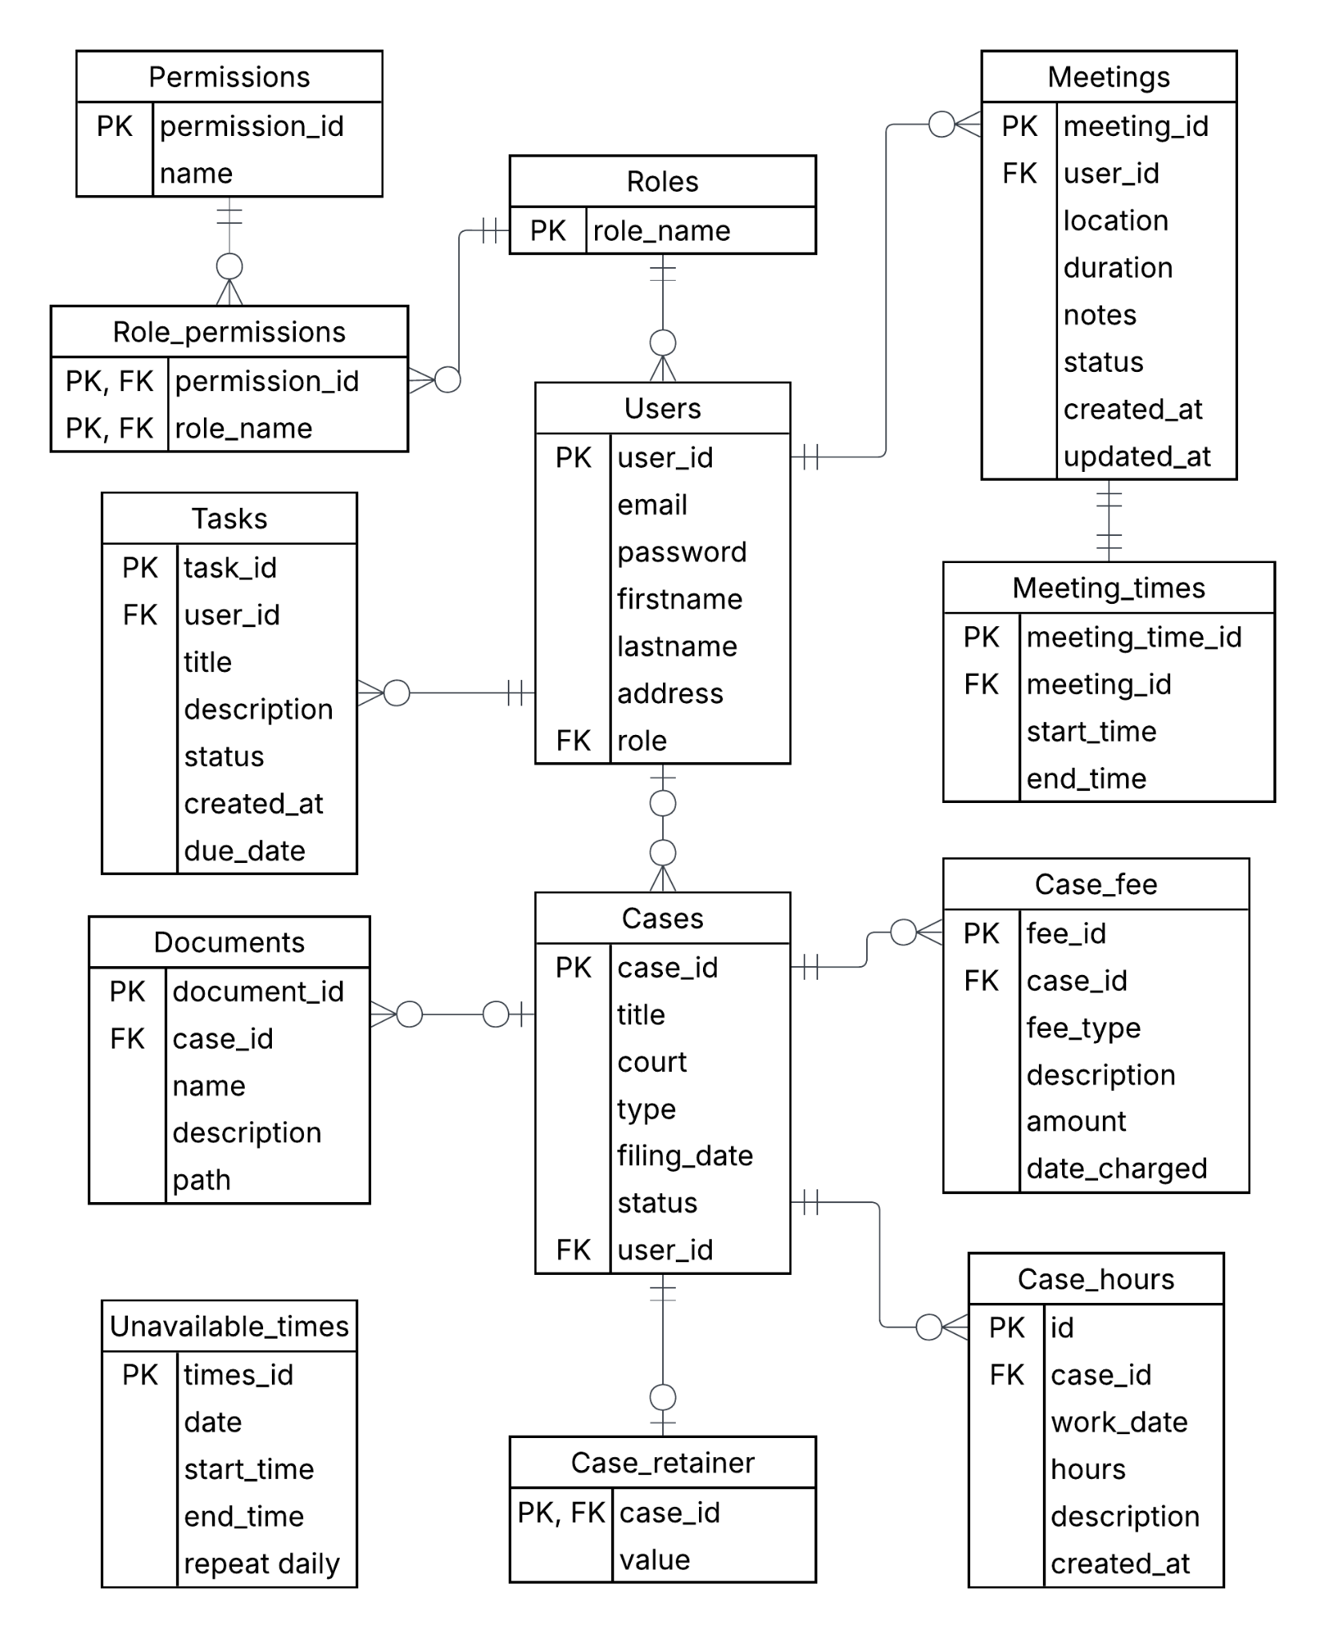

7.2.2 Tables
The database uses a MySQL relational schema. Tables are identified with Primary Keys (PKs). They may also be identified using Alternate Keys (AKs). Foreign Key (FKs) maintain the relationships between tables, and constraints ensure the referential integrity constraints.
Roles Table
Attribute | Type | Key | Description
role_name | VARCHAR(20) | PK | The internal role name.
The Roles table will store the role name, which must be accessed each time the user logs in. There are three roles: admin, paralegal, and client.
Permissions Table
Attribute | Type | Key | Description
permission_id | INT | PK | The permission identification number.
name | VARCHAR(75) |  | The name of the permission.
The Permissions table holds all the permission names. A bridge table is needed to map permissions to roles.
Role_permissions Table
Attribute | Type | Key | Description
permission_id | INT | PK, FK | The reference to the Permissions table.
role_name | VARCHAR(20) | PK, FK | The reference to the Roles table.
The Role_Permissions table maps roles to permissions. It fills the many-to-many relationship from roles to permissions. A Role_permissions entry must reference exactly one Role and exactly one Permission. Permissions and Roles may have zero to many role_permissions.
Users Table
Attribute | Type | Key | Description
user_id | INT | PK | The internal user_id.
email | VARCHAR(255) | AK | The user’s unique email address.
password | VARCHAR(100) |  | The user’s hashed password.
firstname | VARCHAR(30) |  | The user’s first name.
lastname | VARCHAR(30) |  | The user’s last name.
phone | VARCHAR(20) |  | The user’s phone number.
address | VARCHAR(255) |  | The user’s address.
role | VARCHAR(20) | FK | The user’s role name that references the Roles table.
The Users table stores data on the system’s users. The attorney needs to easily access this information. The system uses the login and role data to limit user access when they log in.
Tasks Table
Attribute | Type | Key | Description
task_id | INT | PK | The internal task identification number.
user_id | INT | FK | The reference to the task’s associated User.
description | VARCHAR(250) |  | The task’s description.
can_complete_digitally | BOOLEAN |  | True if the user can complete the task on the website. Otherwise, false.
status | VARCHAR(20) |  | Either pending or completed. Pending by default.
completion_notes | VARCHAR(250) |  | The notes added at completion.
completion_file | VARCHAR(200) |  | The location of the file uploaded to the task.
completed_at | TIMESTAMP |  | The time the task was completed.
created_at | TIMESTAMP |  | The time the task was created
The Tasks table will help the attorney track and communicate what he needs from his users. Select statements will clearly display this information to users, keeping them accountable. A task must have exactly one associated user. A user may have zero to many associated tasks.
Meetings Table
Attribute | Type | Key | Description
meeting_id | INT | PK | The internal meeting ID.
location | VARCHAR(255) |  | The meeting place.
duration | INT |  | The estimated duration in minutes.
notes | TEXT |  | The creator’s notes for the meeting,
status | ENUM |  | The status of the meeting.
user_id | INT | FK | The reference to the meeting’s associated User.
created_at | TIMESTAMP |  | The time the meeting was created.
updated_at | TIMESTAMP |  | The time the meeting was updated.
The Meetings table stores data on meetings. Users may create meetings by inputting the location and duration data. The attorney will update the status in the enumeration of pending, confirmed, cancelled, no_show, and complete, with pending as default. The notes field is optional. The created_at is the current_timestamp, and the updated at is current_timestamp on update.
Meeting_times Table
Attribute | Type | Key | Description
meeting_time_id | INT | PK | The unique identification number.
meeting_id | INT | FK | The reference to the Meetings table.
start_time | DATETIME |  | The starting time of the meeting.
end_time | DATETIME |  | The end time of the meeting.
The Meeting_times table stores the normalized times of meetings. A Meeting_times entry will reference exactly one Meeting, and a Meeting will also reference exactly one Meeting_time.
Unavailable_times Table
Attribute | Type | Key | Description
times_id | INT | PK | The identification number.
date | DATE |  | The date to make a time unavailable.
start_time | TIME |  | The starting time of unavailability.
end_time | TIME |  | The ending time of unavailability.
repeat_daily | BOOLEAN |  | True if the time should be unavailable every day. Otherwise, false.
The Unavailable_times table stores times that the attorney will designate as unbookable for meetings. This is important for the logic tier check before inserting new meetings or times.
Cases Table
Attribute | Type | Key | Description
case_id | INT | PK | The case identification number.
title | VARCHAR(100) |  | The tile of the case.
court | VARCHAR(100) |  | The name of the courthouse.
type | VARCHAR(30) |  | The type of case.
filing_date | DATE |  | The date filed.
status | VARCHAR(20) |  | The status of the case.
user_id | INT | FK | The reference to a User.
The Cases table stores basic case information. The attorney and his clients will access this centralized case information, making their communication easier.
Case_fees Table
Attribute | Type | Key | Description
fee_id | INT | PK | The fee identification number.
case_id | INT | FK | The reference to the case.
fee_type | VARCHAR(50) |  | The type of fee.
description | VARCHAR(200) |  | The description of the fee.
amount | DECIMAL(10,2) |  | The fee value in USD..
date_charged | DATE |  | The date of the fee.
The Cases_fee table holds information on the fees associated with cases. A fee will refer to exactly one case. A case could have zero or many fees.
Case_Hours Table
Attribute | Type | Key | Description
hours_id | INT | PK | The identification number.
case_id | INT | FK | The reference to the associated Case.
work_date | DATE |  | The date of the hour.
hours | DECIMAL(4,2) |  | The amount of time.
description | VARCHAR(250) |  | The description of the logged work.
created_at | TIMESTAMP |  | The time the hour was logged.
The Case_hours table tracks hours the attorney spends on cases. He will manually log this time. Created_at will become the current_timestamp. A case may be created without any logged hours, so a case can have zero to many hours. A Case_hours entry will have exactly one associated case.
Case_retainers Table
Attribute | Type | Key | Description
case_id | INT | PK, FK | The primary identification number AND the reference to the associated case.
value | INT |  | The retainer balance in USD.
Cases may have associated retainers, which are stored in the Case_retainers table. A case may have zero or one retainer. A retainer will have exactly one associated case.
Documents Table
Attribute | Type | Key | Description
document_id | INT | PK | The document’s identification number.
case_id | INT | FK | The optional reference to the case.
name | VARCHAR(200) |  | The document’s name.
description | VARCHAR(250) |  | The document’s description
path | VARCHAR(200) |  | The document’s path in the file system.
The Documents table allows the web application to access its stored documents. It supports easy document access.
8. IMPLEMENTATION
8.1 REQUIREMENTS IMPLEMENTATION
REQ ID | Mandatory / Optional | Implemented milestone #3
REQ-1 | Mandatory | Yes
REQ-2 | Mandatory | Yes
REQ-3 | Mandatory | Yes
REQ-4 | Mandatory | Yes
REQ-5 | Mandatory | Yes
REQ-6 | Optional | No
REQ-7 | Optional | No
REQ-8 | Mandatory | Yes
REQ-9 | Mandatory | Yes
REQ-10 | Mandatory | Yes
REQ-11 | Mandatory | Yes
REQ-12 | Mandatory | Yes
REQ-13 | Mandatory | Yes
REQ-14 | Mandatory | Yes
REQ-15 | Mandatory | Yes
REQ-16 | Mandatory | Yes
REQ-17 | Mandatory | Yes
REQ-18 | Mandatory | Yes
REQ-19 | Mandatory | Yes
REQ-20 | Mandatory | Yes
REQ-21 | Mandatory | Yes
REQ-22 | Mandatory | Yes
REQ-23 | Mandatory | Yes
REQ-24 | Mandatory | No
REQ-25 | Mandatory | Yes
REQ-26 | Mandatory | No
REQ-27 | Mandatory | No
REQ-28 | Mandatory | No
REQ-29 | Mandatory | No
REQ-30 | Mandatory | Yes
REQ-31 | Mandatory | No
REQ-32 | Mandatory | Yes
REQ-33 | Mandatory | Yes
REQ-34 | Mandatory | Yes
REQ-35 | Optional | No
REQ-36 | Optional | No
REQ-37 | Mandatory | Yes
REQ-38 | Mandatory | Yes
REQ-39 | Mandatory | Yes
REQ-40 | Mandatory | Yes
REQ-41 | Mandatory | Yes
NFR-1 | Mandatory | Yes
NFR-2 | Mandatory | Yes
NFR-3 | Mandatory | Yes
NFR-4 | Mandatory | Yes
OSAR-1 | Mandatory | Yes
OSAR-2 | Mandatory | Yes
OSAR-3 | Mandatory | Yes
8.2 GITHUB LINK
https://github.com/jasondchandler/Software-Engineering-Project

